1. Boot Up your system and on the Grub2 boot Menu screen, Press **e** on the Keyboard to enter. Grub Edit Mode

2. Replace "rhgb quiet" by

init=/sysroot/bin/sh

3. Press Ctrl+X

4.

mount -o remount,rw  /sysroot

chroot /sysroot

passwd root

or

passwd debu

Enter Password

touch /.autorelabel

# exit  
# exit

reboot

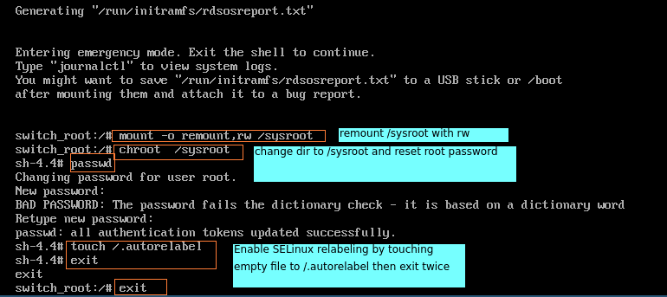

* How to check root password in user debu by terminal?

ssh root@localhost